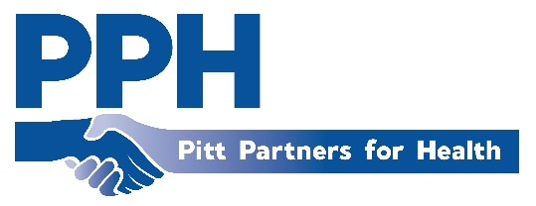
Pitt Partners for Health
Minutes
November 10th, 2022

In Attendance
Allison Swart, Alice Keene, Amanda Sparling, Analee Reed, Angie Watson, Banesa Berumen, Brandie Garner, Brenda Leigh, Bonnie Jean Kuras, Catherine Nelson, Christopher Woods, Ce’Nedra Dillard, De’Vette Thomas, Diane Wactor, Devinder Culver, Gerri Ashe, Gretchen Wilson, JaQuaious Miller (intern), Jane Rose, Jennifer Lewis, Jermain McNair, Jim McArthur, Karen Koch, Kahla Hall, Laurie Reed, Lydia Best, Makala Treece(student), Marie Welch, Mary Hall, Megan, Minerva Freeman, Missy Barrow, Qua’Tavia White, Rod Debs, Sharon Rochelle, Skip Cummings, Stacey Greenway, Tiffany Thigpen, Valarie Walker, Vicki Doughtery.

Welcome/Minutes
Robin welcomed the group and led introductions.

Health Observances
November 13th – ECU women’s basketball team will be hosting a diabetes awareness game at 2pm. Angie Watson is able to give out free tickets and participants are encouraged to wear blue
November 14th at 3pm at the Ag center will be a diabetes comedy hour

HPHC Updates
Upcoming HPHC Bi-State Learning Session on November 30th
Objectives
- Hear communications strategies from other coalitions and look ahead to communicating value and impact in 2023.

- Look into the application of RBA Turn the Curve thinking to design or enhance equity informed PSE/EBI strategy.

- Gain a deeper understanding of Scorecard and where your HPHC coalition aligns

Special Presentation & Speakers
What is GREAT about Gratitude – Bonnie Jean Kuras, TEDI Bear Child Advocacy Center.
Associations between Church Denomination and Health Priorities of Congregation in Memphis, TN – Analee Reed

PPH Elections
Presentation of Slate –
Chair: Amanda Sparling and De’Vette Thomas
Vice-Chair: Jim McArthur, Gretchen Wilson, Missy Barrow, Valarie Walker, and Gerri Ashe
Community Representatives – Rod Debs, Jane Rose, Lydia Best, Valarie Walker, and Antonio Milton
Election Process – The voting process will take place virtually via survey.

December Meeting
Holiday Festivities – fashion show and pot luck

Agency Announcements
Joining Our Voices: Envisioning the Future of Serious Illness Care – The NC Serious Illness coalition will be having a virtual conference November 14th – 18th from 8:30am-9:30am to discuss the future of serious illness care in North Carolina.
Wining Up – On November 30th there will be a diabetes awareness lunch and learn on November 30th at AmeriHealth Caristas. Registration is free but must be completed via Eventbrite.
Feast but not Fry Cooking with Carmen – There will be upcoming diabetes cooking classes on Tuesday’s and Thursdays at AmeriHealth Caritas NC. Registration is free but must be completed via Eventbrite.
Jolly Jamboree – The health department will be hosting a holiday event with refreshment and activities to help and share resources with families December 15th from 1pm-7pm at the Ag center.

Next meeting December 8th

